31 May 2022

Full Name: Artur Nagaev Student ID: 70230

WELLS INTERNATIONAL COLLEGE

Contribute to Organizational Privacy and Contingency Plans

Assessment Two

|  |  |  |  |
| --- | --- | --- | --- |
| Name of Student | Artur Nagaev | ID | 70230 |

**Assessment 2 – Research**

Contents

Task 1-Multiple Choice Questions: 3

Index 16

#### Instructions

This is an in-class closed book written assessment. Answer all the questions on the paper provided by your Trainer.

#### Duration:

Trainer will set the duration of the assessment.

### Intro to Intellectual Property Law Part III: What is Copyright Law? - LexologyTask 1-Multiple Choice Questions:

1. Intellectual Property Rights (IPR) protect the use of information and ideas that are of
   1. Ethical value
   2. Moral value
   3. Social value
   4. Commercial value

**Refer:** <https://en.wikipedia.org/wiki/Intellectual_property>

**Intellectual property (IP)** is the property of your mind or proprietary knowledge. Basically, the productive new ideas you create. It can be an invention, trade mark, design, brand, or the application of your idea.

**Comment:** Intellectual property (IP) is a category of property that includes intangible creations of the human intellect.

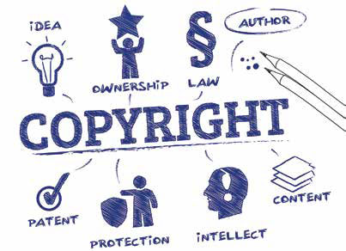

1. The term ‘Intellectual Property Rights’ covers
   1. Copyrights
   2. Know-how
   3. Trade dress
   4. All of the above

**Refer:** <https://pitt.libguides.com/copyright/definitions>

|  |
| --- |
| **Intellectual property rights** are the rights given to persons over the creations of their minds. They usually give the creator an exclusive right over the use of his/her creation for a certain period of time. |

**Comment:** The most well-known types are copyrights, patents, trademarks, and trade secrets.

1. 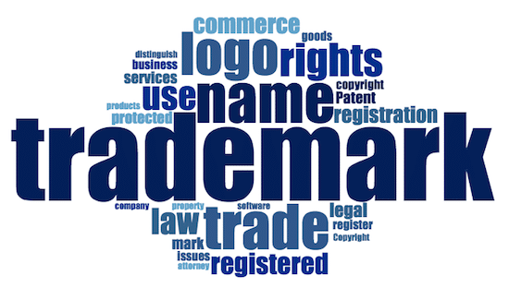The following cannot be exploited by assigning or by licensing the rights to others.
   1. Patents
   2. Designs
   3. Trademark
   4. All of the above

**Refer:** <https://www.ipaustralia.gov.au/trade-marks/understanding-trade-marks/trade-mark-basics>

|  |
| --- |
| Intellectual property includes copyright of publicly available material, but also extends to less tangible assets and knowledge, such as patents, **trademarks**, designs, trade secrets and ‘know-how’. |

**Comment:** A trade mark is a way of identifying a unique product or service. It's a form of brand protection which distinguishes between your products or services and those belonging to your competitors.

1. 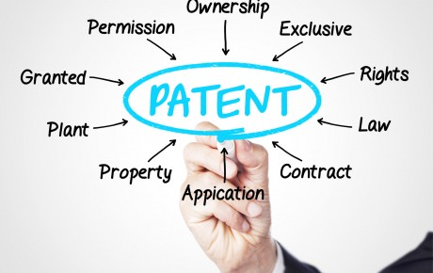The following can be patented
   1. Machine
   2. Process
   3. Composition of matter
   4. All of the above

**Refer:** <https://www.ipaustralia.gov.au/patents/understanding-patents/types-patents/what-can-be-patented>

|  |
| --- |
| A **patent** is a right that is granted for any device, substance, method or process that is new, inventive and useful.  A **patent** is a legally enforceable right to commercially exploit the invention for the life of the patent. |

**Comment:** Patent protection can be applied to a wide range of inventions. In addition to traditional inventions (such as appliances and mechanical devices) protection can also cover:

* computer-related inventions
* business methods
* biological inventions
* micro-organisms and other biological materials

1. Which of these rights isn't generally regarded as part of designs law?
   1. Registered designs law
   2. Copyright
   3. Trade mark law
   4. Design Right under Part III of the CDPA

**Refer:** <https://alderip.com.au/blog/what-is-a-common-law-or-unregistered-trademark-and-does-it-offer-protection/>

|  |
| --- |
| **Trade mark law** requires that a trade mark be capable of distinguishing the goods or services of one trader from those of another, so consumers are not confused as to who they are buying from and who holds the intellectual property rights of that brand. |

**Comment:** The Australian trademark law is based on a common-law practice that requires a brand to

have built up reputation in the region in which a company files its common-law trademark. Common

law in this sense provides limited protection for things like brand names, logos, phrases, packaging etc.

1. 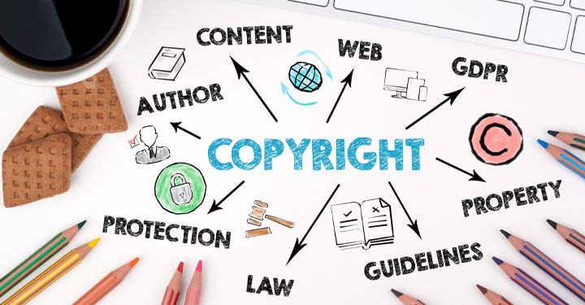To enforce copyright to prevent a product from being copied:
   1. The claimant's product must be represented in an artistic work.
   2. Articles made to the design must have been marketed.
   3. The defendant's product must be a substantial copy of the claimant's product.
   4. The claimant's designer must have created the design for the claimant's product in the form of a drawing or a model that is an artistic work.

**Refer:** <https://en.wikipedia.org/wiki/Copyright_infringement>

|  |
| --- |
| A **copyright** is a type of [intellectual property](https://en.wikipedia.org/wiki/Intellectual_property) that gives its owner the exclusive right to copy and distribute a [creative work](https://en.wikipedia.org/wiki/Creative_work), usually for a limited time. |

**Comment:** Copyright infringement (colloquially referred to as piracy) is the unlawful use of works protected by copyright law without permission for a usage where such permission is required, thereby infringing certain exclusive rights granted to the copyright holder, such as the right to reproduce, distribute, display or perform the protected work, or to make derivative works

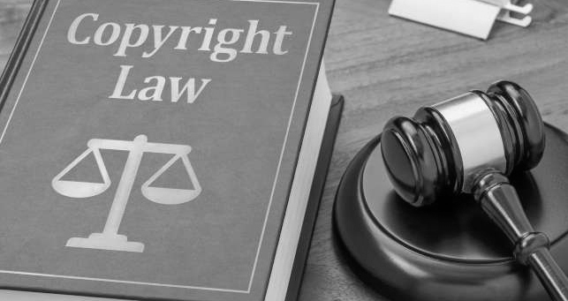

1. Copyright law protects:
   1. Tangible property.
   2. Intangible property.
   3. The name of a particular good or service.
   4. Ideas contained in varied forms of expression.

**Refer:** <https://dawnellmoreblog.com/tangible-mean-comes-copyright/>

|  |
| --- |
| The **copyright law** states that a work must be ‘fixed’ in a tangible medium of expression when its embodiment in a copy or phonorecord, by or under the authority of the author, is sufficiently permanent or stable to permit it to be perceived, reproduced, or otherwise communicated for a period of more than transitory duration. |

**Comment:** Whether you can touch the copyrighted work or not, if it is permanently stored in a medium that can be copied, accessed or transmitted, then it's considered to be fixed into a tangible medium. This allows a law that was originally written for books and physical forms of music, works for internet created work.



1. While sharing some similarities, committing plagiarism and violating copyright are different because plagiarism involves:
   1. Using someone else's work as if it were your own.
   2. Distributing someone else's work.
   3. Reproducing someone else's work.
   4. All of the above.

**Refer:** <https://researchguides.uic.edu/c.php?g=252209&p=1682805>

|  |
| --- |
| **Plagiarism** is a type of intellectual theft. Plagiarism can take many forms, from deliberate cheating to accidentally copying from a source without acknowledgement. |

**Comment:** Copyright infringement includes the unauthorized or unlicensed copying of a work subject to copyright. **Plagiarism** is using someone else's work or ideas without giving proper credit. In other words, because you are not giving attribution to the owner of the original work or idea -- you are presenting the idea or thought as your own.

1. 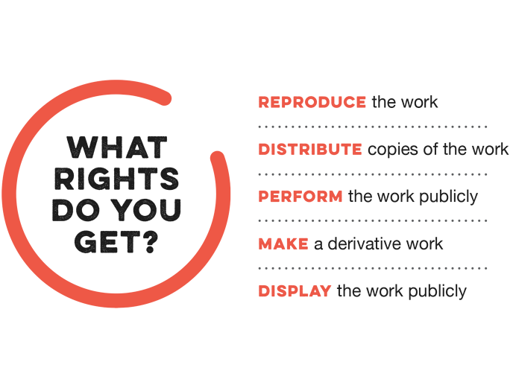The exclusive rights that apply to copyright owners include the right of:
   1. Public distribution of the work.
   2. Reproduction of the work.
   3. Preparation of derivative works.
   4. All of the above.

**Refer:** <https://www.artslaw.com.au/information-sheet/copyright/>

|  |
| --- |
| **Copyright** is a bundle of rights which protects certain subject matter from being copied or used in particular ways without the copyright owner’s permission. |

**Comment:** The copyright owner has certain exclusive rights to use the copyright material in certain ways, and control the use of it by anyone else. Different exclusive rights apply to different subject matter. Depending on the subject matter, some of the exclusive rights include the right to control the use and reproduction of the material, the right to put the material online, the right to make copies available to the public for the first time and the right to perform the material in public.



1. Before a copyrighted work like a book may be printed:
   1. The book must be registered with the Copyright Office.
   2. Consent of the copyright owner must be obtained.
   3. The copyright symbol must be affixed to the book.
   4. None of the above.

**Refer:** <https://www.copyright.com.au/about-copyright/>

|  |
| --- |
| To achieve its objectives, the copyright system treats different uses of content in different ways. Some uses [require permission](http://www.copyright.com.au/about-copyright/permission/), enabling the copyright owner to set the terms of use. |

**Comment:** There is no registration system for copyright under Australian law. Certain forms of expression, such as text, images and music, are automatically covered by copyright under the Copyright Act.

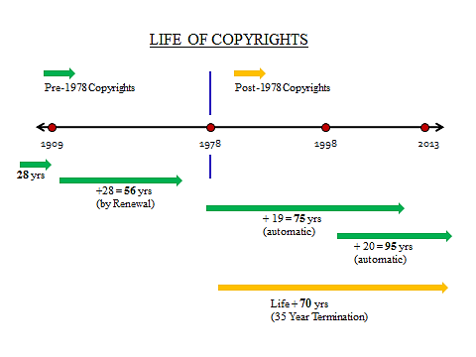

1. Excluding "work for hires," a sole-authored original work created after 1978 receives copyright protection for:
   1. 56 years.
   2. 95 years.
   3. 67 years.
   4. The life of the creator plus 70 years.

**Refer:** <https://www.copyright.gov/help/faq/faq-duration.html>

**Comment:** The term of copyright for a particular work depends on several factors, including whether it has been published, and, if so, the date of first publication. As a general rule, for works created after January 1, 1978, copyright protection lasts for the life of the author plus an additional 70 years.

1. The Digital Millennium Copyright Act (DMCA):
   1. Provides exemptions from copyright infringement claims to Internet service providers (ISPs) who are merely acting as conduits.
   2. Establishes compulsory licensing for the transmission of music over the Internet.
   3. Prevents the circumvention of technological measures designed to protect copyrighted works.
   4. All of the above.

**Refer:** <https://www.wired.com/2016/06/hacker-lexicon-digital-millennium-copyright-act/>

|  |
| --- |
| **The Digital Millennium Copyright Act** criminalizes production and dissemination of technology, devices, or services intended to circumvent measures that control access to [copyrighted](https://en.wikipedia.org/wiki/Copyright) works (commonly known as [digital rights management](https://en.wikipedia.org/wiki/Digital_rights_management) or DRM). |

**Comment:** The DMCA was passed in 1998 as an anti-piracy statute effectively making it illegal to circumvent copy protections designed to prevent pirates from duplicating digital copyrighted works and selling or freely distributing them.

1. Basil is a designer who works for Meteor Motors Ltd, a company which manufactures specialist sports cars which are built on a timber frame. For a forthcoming press release about a new model of car (the Meteor Merlin), Basil made a three-dimensional space-frame replicating the new revolutionary timber frame to be used for the Merlin. He built it from engineering drawings using balsa wood (a very lightweight wood which possesses little strength but is useful for modelling) with glued joints. The real cars will be built using a strong ash frame with sturdy bolted joints. Which one of the following best describes Basil's balsa wood and glue space-frame from a copyright perspective?
   1. It is not protected by copyright as copyright does not protect industrial designs
   2. It is not an artistic work on the basis of being a sculpture or a work of artistic craftsmanship.
   3. Anyone copying the space-frame will infringe the copyright in the drawings indirectly as these are protected irrespective of artistic quality
   4. As the space-frame will not be seen in normal use of the Merlin, being covered by metal panels and body parts, there can be no artistic copyright (which requires eye-appeal) in the frame nor in the drawings as these lack artistic quality, being engineering drawings

**Refer:** <https://www.dacs.org.uk/knowledge-base/frequently-asked-questions>

**Comment:** Copyright covers artworks such as painting, graphic works, photographs, sculptures, collages, works of architecture and works of artistic craftsmanship. Most artistic works are protected irrespective of artistic quality. This is a requirement for works of architecture and artistic craftsmanship, however.

1. Roger is a computer programmer and is employed by a software development company known as Programmers R Us Ltd. A retail organisation known as Acme Trading Ltd asked Programmers R Us to write some computer software to handle Acme's accounts and paid Programmers R Us a fee of £87,500 for the work. All the work was carried out by Roger at Acme's premises and on Acme's computer during a period of 10 months. Roger was paid an hourly rate (£17.25 per hour) by Programmers R Us for his work on the project. There is nothing in writing to say who owns the copyright subsisting in the computer software and there is no written assignment of copyright. There is no express or implied agreement as between Roger and Programmers R Us as to copyright ownership. Which one of the following most accurately describes the position as regards ownership of copyright in the computer program?
   1. Roger owns the copyright at law and at equity as he created the software. Any presumption that his employer, Programmers R Us owns it is displaced because he created the software at Acme's premises and using Acme's equipment
   2. Acme Trading Ltd owns the legal and beneficial copyright in the software because it paid for it to be written, there was no agreement to the contrary and Programmers R Us owes a fiduciary duty to Acme
   3. As there was no formal assignment of copyright complying with the Copyright, Designs and Patents Act 1988, Programmers R Us is the first owner of the legal title to the copyright as Roger created the software as an employee in the course of his employment? However, a court is likely to hold that Acme is the beneficial owner of the copyright or at least has an implied licence to continue to use it
   4. Acme Trading and Programmers R Us are joint owners of the legal and beneficial copyright. This will enable Acme to continue to use the software and both Acme and Programmers R Us to licence the software to third parties

**Refer:** <https://www.edwardallenlaw.com/difference-between-copyright-assignments-and-licenses/>

**Comment:** In an assignment of copyright rights, the owner sells his or her ownership rights to another party and has no control over how the third party uses those rights.



1. Naomi MacDonald is a poet who wrote a series of poems on the theme of 'The Four Seasons' for Limerick Publishing plc ('LPP'). Naomi granted LPP an exclusive licence to publish the poems as a collection in book form under the name 'The Four Seasons Poems'. There were no terms in the licence agreement relating to Naomi's moral rights. LPP published and sold the entire print run of 800 copies of the book with Naomi being acknowledged as the author on the cover and flyleaf.

However, LPP decided not to reprint the book and informed Naomi accordingly. Naomi subsequently assigned the copyright in her Four Seasons Poems to Epic Sagas Ltd ('ESL'). A term in the assignment stated that Naomi was to be identified as author under her newly adopted pseudonym 'Helena Campbell'. ESL duly printed copies of the poems and put them on sale. They bore the author's name as Naomi MacDonald as a result of an oversight by ESL's printing sub-contractor. Which one of the following statements is correct?

* 1. ESL is in breach of Naomi's right to be identified as author as she specified the pseudonym 'Helena Campbell' in the assignment and that form of identification only must be used
  2. Although there is potential liability for failing to use the specified form of identification, ESL is not liable as the mistake was that of its printing sub-contractor who will be liable to Naomi for its error
  3. As the book of poems was lawfully first published with the name Naomi MacDonald as author, this overrides any later assertion of the right to be identified as author
  4. There is no infringement of Naomi's right to be identified by author by ESL as using her real name to identify her is a reasonable form of identification

**Refer:** <https://www.artslaw.com.au/information-sheet/moral-rights/>

|  |
| --- |
| **Moral rights** protect the personal relationship between a creator and their work even if the creator no longer owns the work, or the copyright in the work. Moral rights concern the creator’s right to be properly attributed or credited, and the protection of their work from derogatory treatment. |

**Comment:** Moral rights are personal rights contained in the Copyright Act 1968 that connect creators to their work.

1. Frederick is a well-known commercial artist who is employed by Graphic Designs Ltd ('GDL'). As part of his employment duties, Frederick produced an original drawing depicting an angler fishing from a boat in the process of reeling in a large barracuda fish. The drawing captured the excitement of the event. Frederick's name did not appear on the drawing. GDL assigned the copyright in the drawing to Southern Sports Ltd ('SSL'), which applied copies of the drawing to T-Shirts, which were sold in large numbers to keen anglers. A charitable organisation, Campaign Against Cruel Sports ('CACS') started placing advertisements which include a copy of Frederick's drawing but with the head of the angler replaced by the head of a monstrous devil and to which a slogan had been added stating 'All anglers are sub-human fiends'. CACS did not have SSL's permission to copy or modify the drawing. Frederick was incensed when he saw CACS's advertisement. Which one of the following statements is correct?
   1. If Frederick sued CACS on the basis of the moral right to object to a derogatory treatment of his drawing, CACS would escape liability if it raised a defence based on freedom of expression under Article 10 of the Council of Europe Convention for the Protection of Human Rights and Fundamental Freedoms
   2. As Frederick does not own the copyright in the drawing he has no remedies under copyright law
   3. As Frederick's name does not appear on the drawing he cannot object to the treatment of the work as the right only applies if the author is identified as such on copies of the work
   4. Frederick has a right to object to a derogatory treatment of his work as the modification was not made by or with the authority of the copyright owner providing it amounted to a distortion or mutilation of his drawing or is otherwise prejudicial to his honour or reputation

**Refer:** <https://en.wikipedia.org/wiki/Article_10_of_the_European_Convention_on_Human_Rights>

**Comment**: Article 10 of the European Convention on Human Rights provides the right to freedom of expression and information, subject to certain restrictions that are "in accordance with law" and "necessary in a democratic society". This right includes the freedom to hold opinions, and to receive and impart information and ideas.



1. In relation to infringement of an original work of copyright, which one of the following statements is not correct?
   1. Substantiality is more concerned with quality rather than quantity, in other words, it is the importance of the part taken to the work that has been copied which is the predominant question
   2. Copyright infringement requires, essentially, three things to be shown (i) that copyright subsists in the claimant's work, (ii) that the defendant has copied from the claimant's work (directly or indirectly), and (iii) that the part copied by the defendant is a substantial part of the claimant's work
   3. The part taken from the claimant's work must be a substantial part of that work but need not be a substantial part of the defendant's work
   4. Where an artistic work is copied by converting it from three-dimensions to two-dimensions, or vice versa, the copy must, in the eyes of a non-expert, look like the work copied

**Refer:** <https://www.artslaw.com.au/information-sheet/copyright>

**Comment:** Copyright infringement occurs when copyright material is used in one of the exclusive ways controlled by the copyright owner, without the copyright owner's permission. Infringement can also occur when a 'substantial part' (i.e. a significant or important part) of the material is used.

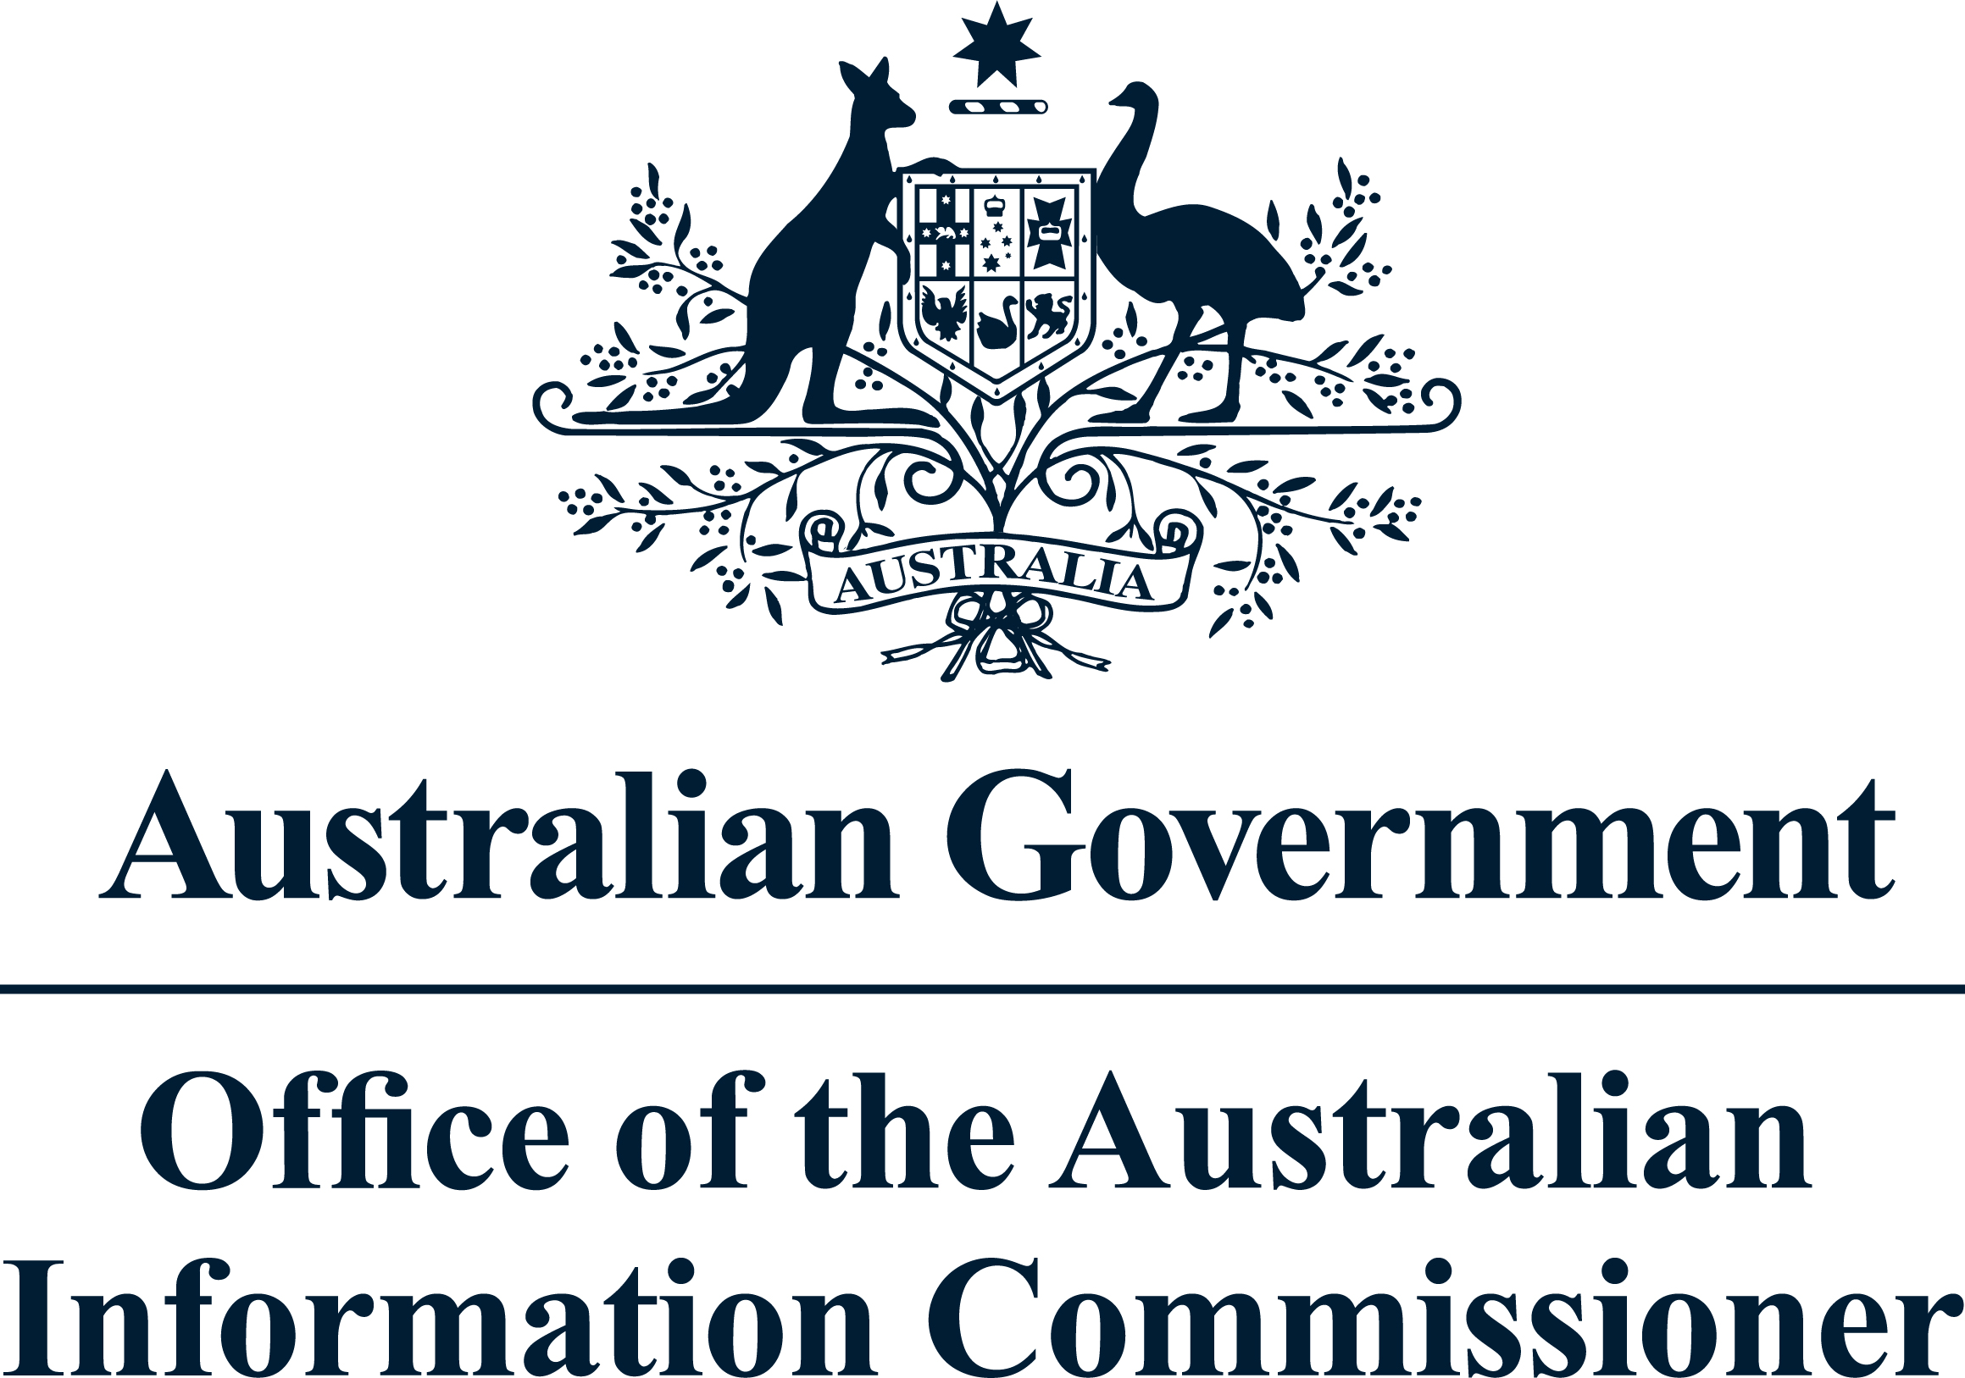

1. Privacy in Australia is overseen by:
   1. Australian Security Intelligence Organisation
   2. Australian Securities Commission
   3. The Privacy Commissioner
   4. The Privacy Ombudsman

**Refer:** <https://www.oaic.gov.au/about-us/>

**Comment:** The Office of the Australian Information Commissioner (OAIC) is an independent agency within the Attorney General's portfolio. Their primary functions are privacy, freedom of information and government information policy.

1. The legislation which sets out the rules for privacy in Australia is called:
   1. The Official Secrets Act
   2. The Freedom of Information Act
   3. The Corporations Law
   4. The Privacy Act

**Refer:** <https://www.ag.gov.au/rights-and-protections/privacy>

**Comment:** The Privacy Act 1988 (Privacy Act) is the principal piece of Australian legislation protecting the handling of personal information about individuals. This includes the collection, use, storage and disclosure of personal information in the federal public sector and in the private sector.



1. The Privacy Act applies to whom?
   1. Government departments only
   2. Large corporations only
   3. Private enterprise only
   4. All of the above

**Refer:** <https://www.ag.gov.au/rights-and-protections/privacy>

**Comment:** The Privacy Act provides 13 Australian Privacy Principles (APPs). The APPs apply to government agencies and private sector organisations with an annual turnover of $3 million or more. The APPs are principles-based—protecting privacy while not burdening agencies and organisations with inflexible prescriptive rules.



1. The Privacy Act is concerned with how all personal information is used and stored. This statement is:
   1. True
   2. False

**Refer:** <https://www.oaic.gov.au/privacy/guidance-and-advice/what-is-personal-information/>

**Comment:** The Privacy Act defines 'personal information' as: 'Information or an opinion about an identified individual, or an individual who is reasonably identifiable: whether the information or opinion is true or not; and. whether the information or opinion is recorded in a material form or not.

1. People have rights to access information a company or Government Department holds about them.
   1. True
   2. False

**Refer:** <https://www.oaic.gov.au/privacy/the-privacy-act/rights-and-responsibilities>

**Comment:** The Privacy Act allows you to: know why your personal information is being collected, how it will be used and who it will be disclosed to. have the option of not identifying yourself, or of using a pseudonym in certain circumstances. Ask for access to your personal information (including your health information).

1. An organisation should only use or disclose a person's information for the purpose it was collected unless the person has consented to it being used in another way.
   1. True
   2. False

**Refer:** <https://www.oaic.gov.au/privacy/your-privacy-rights/your-personal-information/collection-of-personal-information>

**Comment:** An organisation may only collect your personal information that is reasonably necessary for their work. An agency may only collect your personal information that is directly related to their work. They don't need your consent unless the information is sensitive.

1. Define morality
   1. What is considered as correct within a society
   2. Making the right decision's where there is a chance to do wrong
   3. Defining what is right and wrong for an individual or a community
   4. Where individuals have a conscious choice to make a right and ethical decision

**Refer:** <https://ethicsunwrapped.utexas.edu/glossary/morals>

**Comment:** Morals are the prevailing standards of behavior that enable people to live cooperatively in groups. Moral refers to what societies sanction as right and acceptable.

1. What is business ethics?
   1. The study of business situations, activities, and decisions where issues of right and wrong are addressed
   2. Defined as decisions organisations make on issues that could be considered right or wrong
   3. Ethics that can be applied to an organisation’s practises
   4. Ethical processes businesses use in order to achieve a good ethical standard

**Refer:** <https://en.wikipedia.org/wiki/Business_ethics>

|  |
| --- |
| **Business ethics** (also known as corporate ethics) is a form of [applied ethics](https://en.wikipedia.org/wiki/Applied_ethics) or [professional ethics](https://en.wikipedia.org/wiki/Professional_ethics), that examines ethical principles and moral or ethical problems that can arise in a business environment. |

**Comment:** Business ethics refers to contemporary organizational standards, principles, sets of values and norms that govern the actions and behavior of an individual in the business organization.



1. Which is not a reason a business engages in business ethics?
   1. To recover a company’s image after a notorious business scandal
   2. To avoid the loss of a good corporate image or being sued for misconduct
   3. To enhance global relationships
   4. To enhance stakeholder relationships
   5. To act with real commitment
   6. To build corporate reputation

**Refer:** <https://www.investopedia.com/ask/answers/040815/why-are-business-ethics-important.asp>

**Comment:** The importance of business ethics reaches far beyond employee loyalty and morale or the strength of a management team bond. As with all business initiatives, the ethical operation of a company is directly related to profitability in both the short and long term.



1. Which one is a purpose of Privacy?
   1. protects individuals from misuse of their personal information
   2. protects the rights of owners of published and unpublished material
   3. ensures equal rights regardless of gender, ability, religion or ethnicity
   4. protects the good name and reputation of individuals and businesses

**Refer:** <https://matomo.org/blog/2014/01/data-privacy-day-january-28th/>

**Comment:** Privacy is important because: Privacy gives us the power to choose our thoughts and

feelings and who we share them with. Privacy protects our information we do not want shared

publicly (such as health or personal finances). Privacy helps protect our physical safety (if our real time

location data is private).

1. There are 10 National Privacy Principles. Which of the following is not the privacy principle?
   1. Organisations must give people the option to interact anonymously whenever it is lawful and practicable to do.
   2. Generally speaking, an organisation should not give an individual access to personal information it holds about that individual on request.
   3. An organisation must take reasonable steps to make sure that the personal information it collects, uses or discloses is accurate, complete and up-to date.
   4. An organisation must have a policy document outlining its information handling practices and make this available to anyone who asks.

**Refer:** <https://www.oaic.gov.au/privacy/australian-privacy-principles>

**Comment:** The Australian Privacy Principles are principles-based law. This gives an organisation or agency flexibility to tailor their personal information handling practices to their business models and the diverse needs of individuals. They are also technology neutral, which allows them to adapt to changing technologies.



1. What are the common security features covered in a system’s functional requirements?
   1. log ins
   2. password policies
   3. open public shells
   4. secure directories
   5. encryption protocols

**Refer:** <https://softwareengineering.stackexchange.com/questions/309512/is-providing-a-user-login-afunctional-requirement-of-a-system>

**Comment:** A login is a function or specific behavior. You either have a login capability or you don't. As such, as requirement, it would be a functional requirement. Performance, say, of login, is a non-functional requirement: a judgement of the quality of the implementation (rather than a feature is present/absent).

1. IT support staff loudly discuss their organisation’s network security problem on a crowded train. This statement relates to which ethical issue.
   1. Reliability
   2. Security
   3. Confidentiality
   4. Proprietary rights
   5. Conflict of interest

**Refer:** <https://www.myaccountingcourse.com/accountingdictionary/ethical-issues>

**Comment:** Ethical issues in business is a situation where a moral conflict arises and must be addressed. In other words, it is an occasion where a moral standard is questioned.

### Index

B

business ethics 13

C

computer programmer 8

copyright 3, 4, 5, 6, 7, 8, 9, 10

copyright law 5

D

Digital Millennium Copyright Act 7

E

ethical issues 15

I

Intellectual property 3

Intellectual Property Rights 3

IT support 15

M

moral rights 9

morality 12

P

patent 3, 4

plagiarism 5

privacy 10, 11, 13

Privacy Act 11, 12

S

sub-contractor 9

T

trade secret 3

trademark 3

trademark law 4